# Table of Contents

Table of Contents 1,2

1.1 Purpose 3

1.3 Definitions, Acronyms and Abbreviations 3

1.4 References 4

1.5 Overview 4

2. Overall Description 4

2.1 Product Perspective 4

2.1.1 System Interface 4

2.1.2 User interface 4

2.1.3 Hardware Interface 5

2.1.4 Software Interface 5

2.1.5 Communication Interfaces 5

2.1.6 Operations 5

2.2 Product functions 6

2.2.1 Context Diagram 6

2.2.2 Use Case Diagrams 7

2.2.3 Use case descriptions /Introductions 10

2.2.3.2 User Characteristics 11

3. Specific Requirements 12

3.1 External interface 12

3.1.1 Web Server 12

3.1.2 PHP Application 12

3.2 Functional Requirements 12

3.2.1 Use Case Scenario 12

3.3 Performance Requirements 13

3.4 Logical database requirements 14

3.5 Design Constraints 14

3.6 Software System Attributes 14

3.6.1 Reliability 14

3.6.2 Security 14

3.6.3 Portability 14

**Table of Figure(s)**

Figure 1: Context Diagram ........................................................................................................ 6

Figure 2: User Login ................................................................................................................... 7

Figure 3: Content Sharing(Upload) ............................................................................................. 8

Figure 5: Search ........................................................................................................................... 9

Figure 6: common links............................................................................................................... 10

1. **Introduction**

## 1.1 Purpose

The purpose of an IoT components selling website is to provide a platform for individuals, businesses, and developers to easily access and purchase the necessary components for their Internet of Things (IoT) projects. The website serves as a centralized marketplace where customers can explore a wide range of IoT components, including sensors, microcontrollers, connectivity modules, actuators, and development boards.

**1.2 scope**

The scope of an IoT components selling website includes offering a diverse range of high-quality IoT components, providing an e-commerce platform for convenient browsing and purchasing, ensuring quality assurance, offering expert guidance and support to customers, keeping them updated with industry trends, facilitating community building among IoT enthusiasts, and potentially integrating with other IoT platforms and tools.

## 1.3 Definitions, Acronyms and Abbreviations

##### 1.3.1 Login

The login page of an IoT components selling website serves as a secure gateway for registered users to access their accounts and personalized features. In short, the login page typically includes the following elements:

1. Username or email field
2. Password
3. Sign up
4. Error Messages and Validation

##### 1.3.2 Home

In home page we display our iot products and also our featured products.

There is a search bar where we can search for our products

##### 1.3.3 Products

The website serves as a centralized marketplace where customers can explore a wide range of IoT components, including sensors, microcontrollers, connectivity modules, actuators, and development boards.

**1.3.4 About**

In about section we give an introduction to our team who made this website

## 1.4 References

1. "E-commerce website design and development for selling Internet of Things (IoT) products" by Trushank Dhanani and Monark Vora Moodle Requirements Brainstorming.pdf
2. E-commerce platforms for IoT product sales" by Kyrylo Babenko
3. IoT as a Service: Business Models for the Next Generation of IoT Components" by Alfonso Nocere

4. Internet of Things (IoT) e-commerce platforms: A systematic literature review" Zahraa S. Hameed

## 1.5 Overview

An IoT components selling website is an online platform where customers can browse, select, and purchase a wide range of components for building IoT projects. The website offers a diverse product range, ensures quality assurance, provides a user-friendly interface, offers expert guidance and support, delivers a seamless shopping experience, keeps customers updated on industry trends, and fosters a community of IoT enthusiasts.

# 2. Overall Description

## 2.1 Product Perspective

The product perspective of an IoT components selling website refers to the features and characteristics that make it a valuable platform for customers seeking to purchase IoT components.

#### 2.1.1 System Interface

Apache will be used as web server. The user inputs data via the web server using HTML forms. The actual program that will perform the operations is written in PHP.

#### 2.1.2 User interface

The new system shall provide a very intuitive and simple interface to the user and the administrator, so that the user can easily navigate through home, products , explore . contact etc

#### 2.1.3 Hardware Interface

##### a) Server side

The web application will be hosted on a web server which is listening on the web standard port, port 80.

##### b) Client side

Monitor screen – the software shall display information to the user via the monitor screen

Mouse – the software shall interact with the movement of the mouse and the mouse buttons. The mouse shall activate areas for data input, command buttons and select options from menus.

Keyboard – the software shall interact with the keystrokes of the keyboard. The keyboard will input data into the active area of the database.

#### 2.1.4 Software Interface

1. Server side

An Apache web server will accept all requests from the client and forward it accordingly. A database will be hosted centrally using XAMPP.

1. Client side

An OS which is capable of running a modern web browser which supports JavaScript and HTML.

#### 2.1.5 Communication Interfaces

The HTPP or HTTPS protocol(s) will be used to facilitate communication between the client and server.

#### 2.1.6 Operations

The product shall have operations to protect the database from being corrupted or accidentally altered during a system failure.

## 2.2 Product functions

#### 2.2.1 Context Diagram

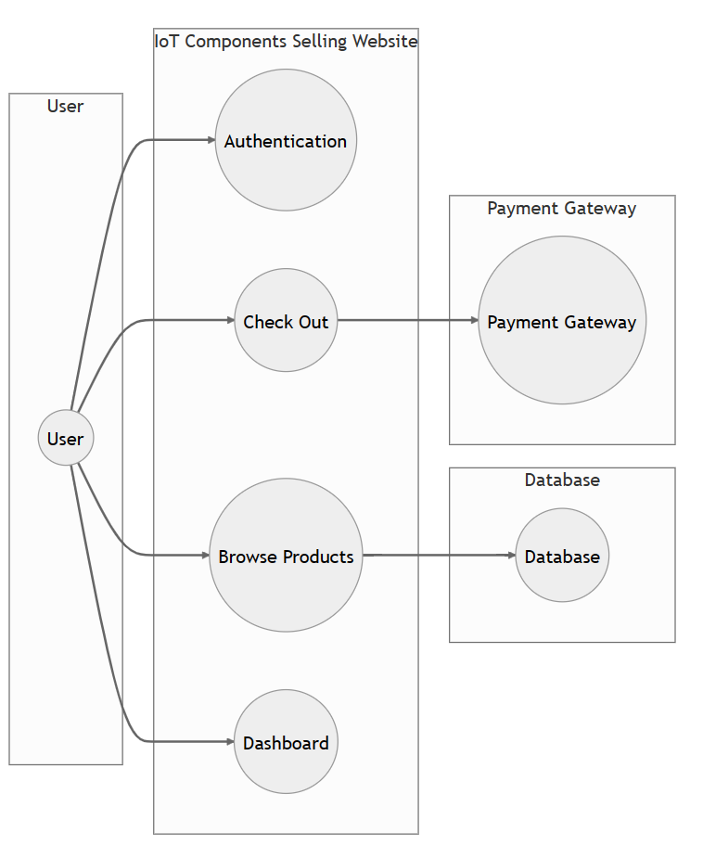

Figure 1: Context Diagram

#### 2.2.2 Use Case Diagrams

###### 2.2.2.1 User Login

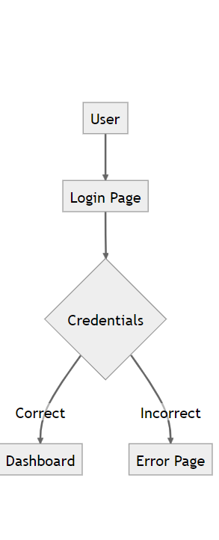

**Figure 2: User Login**

###### 2.2.2.2 Content Sharing (file upload/ Old paper sharing)

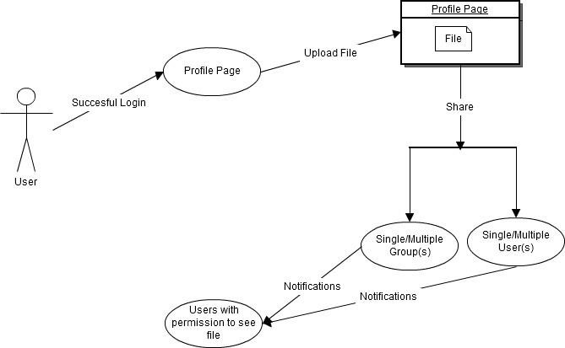

**Figure 3: Content Sharing(Upload)**

###### 2.2.2.3 Search

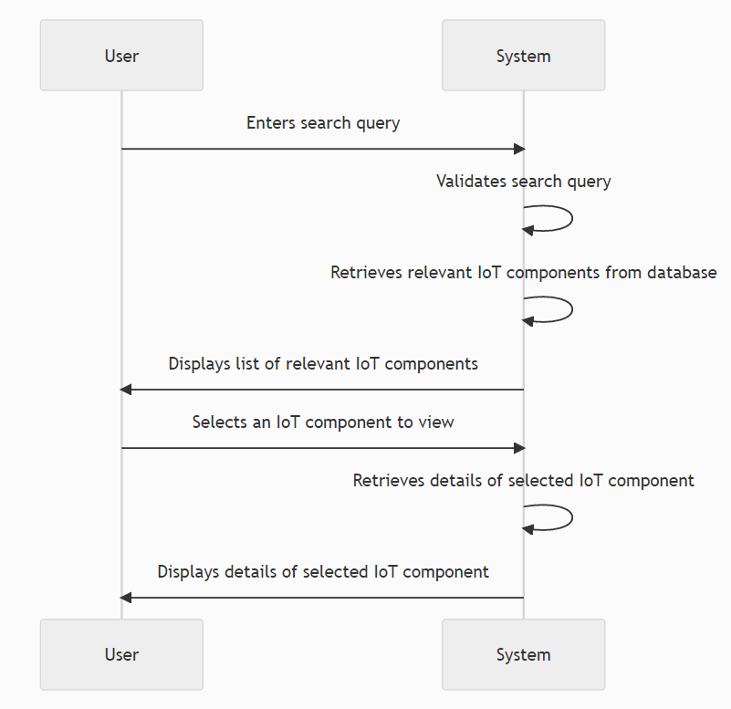

**Figure 4: Search**

###### 2.2.2.4 Common Links

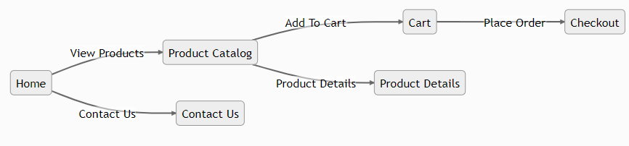

**Figure 5: Common Links**

#### 2.2.3 Use case descriptions /Introductions

2.2.3.1 Search

The search window in an IoT components selling website is a key feature that allows users to quickly find specific components or relevant information. Here's an overview of the search window in an IoT components selling website:

1. Search Bar: The search window typically includes a search bar prominently placed on the website's homepage or header section. The search bar allows users to enter keywords or phrases related to the specific components they are looking for.
2. Search History and Saved Searches: Some websites may include features that allow users to view their search history or save their favorite or frequently used search queries. This enables users to revisit previous searches or quickly access their preferred search criteria in future visits.

The search window in an IoT components selling website plays a crucial role in helping users find the desired components efficiently and navigate the extensive product catalog. It offers search suggestions, advanced filters, sorting options, and refinement features to enhance the user experience and improve the likelihood of finding the right components quickly.

## 2.2.3.2 User Characteristics

In an IoT components selling website, the user characteristics can vary, but typically include the following:

1. Technical Knowledge: Users visiting an IoT components selling website often possess varying levels of technical knowledge. Some users may be experienced professionals or developers familiar with IoT concepts, while others may be beginners or enthusiasts looking to explore IoT projects. The website should cater to users with different levels of technical expertise by providing appropriate product information, guides, and support.
2. Specific Requirements: Users of an IoT components selling website typically have specific requirements for their IoT projects. They may be looking for components that meet certain specifications, compatibility requirements, or industry standards. Understanding and catering to these specific requirements is essential for providing a personalized and satisfactory user experience.
3. Project Scope and Scale: Users may have different project scopes and scales when it comes to IoT implementations. Some users may be working on small-scale personal projects, while others may be involved in larger-scale commercial or industrial deployments. The website should offer a range of components that cater to different project sizes and complexities.
4. Budget Constraints: Users visiting an IoT components selling website may have budget constraints that impact their purchasing decisions. It is important to provide components at various price points to accommodate users with different budget ranges. Additionally, offering cost-effective alternatives or value bundles can be beneficial for budget-conscious users.
5. Industry Focus: Users from different industries may visit the website, each with its unique requirements and applications. Some users may be looking for components specific to smart homes, while others may require components for healthcare, agriculture, manufacturing, or other industries. Understanding the industry focus of users helps in tailoring the product offerings and providing relevant information.
6. Geographical Considerations: Users accessing the website can be from different geographical locations. Consideration should be given to regional factors such as availability, shipping options, and localized support to ensure a seamless experience for users across different regions.
7. Repeat Customers and Loyalty: The website may have repeat customers and loyal users who frequently visit and purchase from the platform. Recognizing and rewarding customer loyalty through loyalty programs, special discounts, or personalized recommendations can enhance the user experience and foster customer satisfaction and retention.

Understanding these user characteristics helps in tailoring the website's design, content, and features to cater to the specific needs of the users, providing them with a personalized and satisfactory experience when searching for and purchasing IoT components.

# 3. Specific Requirements

## 3.1 External interface

#### 3.1.1 Web Server

* Apache will be used as web server:
* The user inputs data via the web server using HTML forms
* The web server executes the PHP as a module and PHP script retrieves the post data if available.
* The web server receives information back from the PHP script. • The web server displays a HTML page as result to the end-user.

#### 3.1.2 PHP Application

The actual program that will perform the operations is written in PHP. All data will be stored in a database.

## 3.2 Functional Requirements

#### 3.2.1 Use Case Scenario

###### 3.2.1.1 Use Case Scenario 1 – User Login

User Login

|  |  |
| --- | --- |
| **Purpose** | User logs in to system using existing profile. |
| **User** | A user with an existing profile. |
| **Input Data** | Profile username and password. |
| **Output Data** | Corresponding page data. |
| **Invariants** | Profile table data and user information. |
| **Pre-conditions** | User is not logged in to a profile, input profile exists in data base, user password matches profile |
| **Basic Flow:** | Webpage looks up profile data Webpage is updated to match new user data. |
| **Alternative Flow(s):** | Invalid password, invalid username, or mismatched username and password redirect to error message and previous page. |
| **Business Rules:** | This allows users to log in to their profile from anywhere. |

Search Result

|  |  |
| --- | --- |
| **Purpose** | A user wants to search for a particular keyword. |
| **User** | Any user of the academic portal. |
| **Input Data** | The keyword. |
| **Output Data** | Search Results. |
| **Invariants** | The user and the portal itself. |
| **Pre-conditions** | User is logged in. |
| **Post-conditions** | Search results. |
| **Basic Flow:** | User logs in, Enters the keyword in the search box, clicks the search button and gets the search results. |

## 3.3 Performance Requirements

Performance requirements in an IoT components selling website include fast page load times, responsive design across devices, scalability to handle increased traffic, quick and accurate search and filtering functionality, secure transactions, efficient order processing and inventory management, minimal downtime, and the implementation of analytics and performance monitoring for continuous improvement. These requirements ensure a smooth and efficient user experience, leading to customer satisfaction and business success

## 3.4 Logical database requirements

## Logical database requirements in an IoT components selling website involve structuring and organizing the database to efficiently store and retrieve data related to products, customers, orders, and other relevant information.

## 3.5 Design Constraints

1. The portal layout will be produced with HTML/CSS.
2. The product will be written in PHP.
3. The output must be compatible with XAMPP local host 80
4. The source code must follow the coding conventions of PHP.
5. System administrators must have access to comprehensive documentation.

## 3.6 Software System Attributes

The software consists of the following elements:

1. The HTML web server
2. The PHP application
3. The XAMPP

#### 3.6.1 Reliability

The reliability of the overall program depends on the reliability of the separate components.

#### 3.6.2 Security

1. Passwords will be saved encrypted in the database in order to ensure the user's privacy.
2. The user's IP will be logged.
3. The system will be protected against vulnerabilities such as SQL injection attacks.

#### 3.6.3 Portability

The application is Linux-based and should be compatible with other systems. Apache, PHP and MySQL programs are practically independent of the OS-system which they communicate with. The end-user part is fully portable and any system using any web browser should be able to use the features of the application.